**4-Program to implement locking algorithm.**

***A locking algorithm***, in the context of concurrent programming and operating systems, is a mechanism used to coordinate access to shared resources in a way that prevents conflicts, race conditions, and data corruption. Locking algorithms are crucial for ensuring mutual exclusion, which means that only one thread or process can access a critical section of code or a shared resource at a time. Locks are used to enforce mutual exclusion by allowing one thread to enter a critical section while blocking others until the lock is released.

**C++ CODE:**

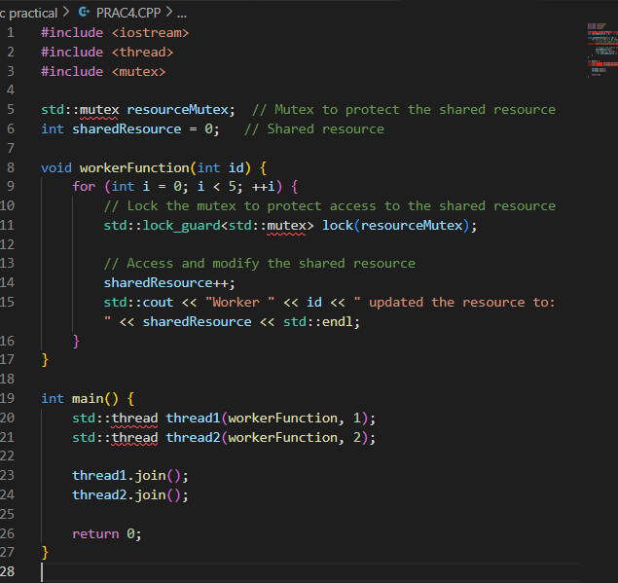

**OUTPUT:**

